Majed Dakkour 201901366

Mobile Development course Project 1 report:

In this project I did an app that you can launch 2 separate games by clicking a button. The first game is “Find the continent “and the other one is “Guess the animal” using Java and XML.

I used spanish and french as a localization for my app by using google translator.

My main menu(home page consists of score and share button and 2 buttons that start the games separately.

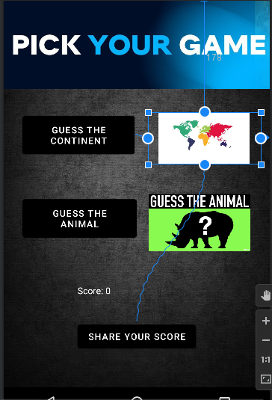

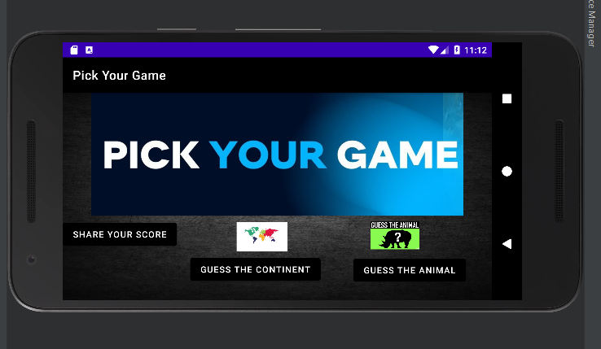

In the first game “ Guess the continent”

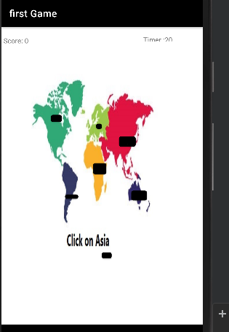

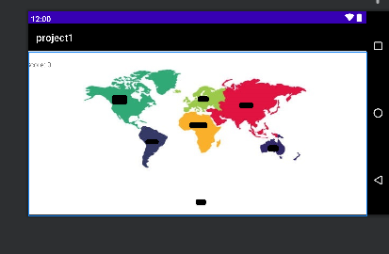

I have a world map that shows all continents and the user has to click on the right continent depending on the question with a timer on top right of the screen (if it reached 30 the scores gets deducted by 2 and the game ends). If the user answer correctly the score is increased by 1 otherwise deduced by 1.

The Second game “Guess the animal” 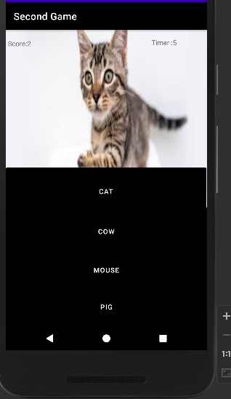

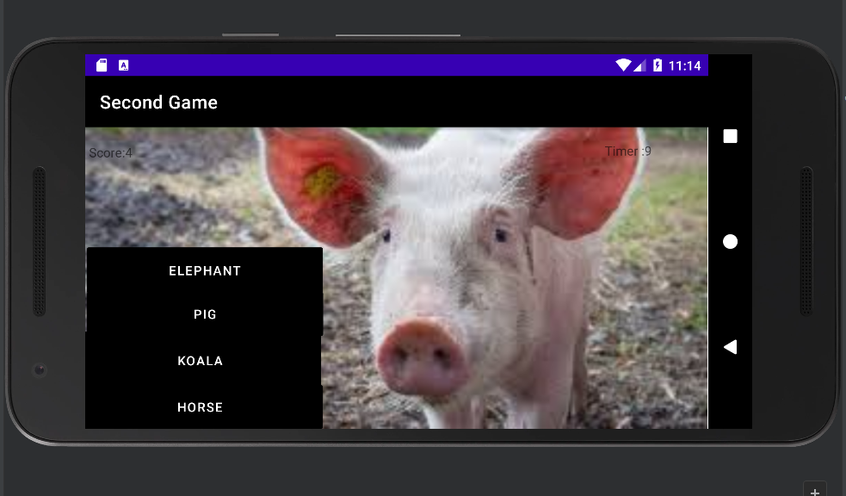

Consists same as game one score/timer but 4 buttons and single image of an animal .Only one correct answer and if the user answers correctly the scores increases by 1 otherwise the scores is deducetd by 1.The questions/buttons are randomly picked .

Finally in the main menu there is a share button feature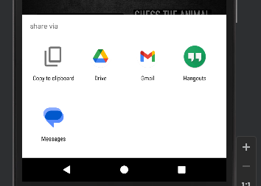 that allows the user to share his/her score via variable ways.

Citiation:

For landscapes: <https://stackoverflow.com/questions/28815769/android-studio-creating-landscape-layouts>

Share button: https://www.stechies.com/add-share-button-android-app/

Life cycle: https://www.youtube.com/watch?v=v4P22qRFzKg&ab_channel=CodesEasy